**DAILY ONLINE ACTIVITIES SUMMARY**

|  |  |  |  |  |  |  |  |  |
| --- | --- | --- | --- | --- | --- | --- | --- | --- |
| **Date:** | **02-07-2020** | | | | | **Name:** | **Deeksha D Poojary** | |
| **Sem & Sec** | **VIII Semester & A Section** | | | | | **USN:** | **4AL16CS026** | |
| **Online Test Summary** | | | | | | | | |
| **Subject** | | **-** | | | | | | |
| **Max. Marks** | | **-** | | **Score** | | | **-** | |
| **Certification Course Summary** | | | | | | | | |
| **Course** | **Introduction to Amazon Elastic Compute Cloud (EC2)** | | | | | | | |
| **Certificate Provider** | | | **Amazon Web Service** | | **Duration** | | | **10 minutes** |
| **Coding Challenges** | | | | | | | | |
| **Problem Statement: Write a program for binary search** | | | | | | | | |
| **Status: COMPLETED** | | | | | | | | |
| **Uploaded the report in Github** | | | | | **YES** | | | |
| **If yes Repository name** | | | | | **deekshapoojari** | | | |
| **Uploaded the report in slack** | | | | | **YES** | | | |

Online Test Details:

NIL

Certification Course 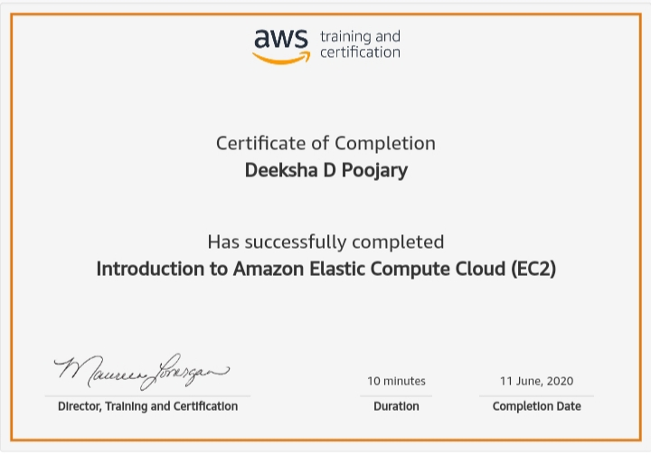Coding Challenges Details:

|  |
| --- |
|  |
|  |
|  |
|  |
|  |
|  |
|  |
|  |
|  |
|  |
|  |
|  |
|  |
|  |
|  |
|  |
|  |
|  |
|  |
|  |
|  |
|  |
|  |
|  |
|  |
|  |
|  |
|  |
|  |
|  |
|  |
|  |
|  |
|  |
|  |
|  |
|  |
|  |
|  |
|  |
|  |
|  |
|  |
|  |
|  |
|  |
|  |
|  |
|  |
|  |
|  |
|  |
|  |
|  |

**Program1:**

|  |  |
| --- | --- |
|  |  |

#include<stdio.h>

int iterativeBsearch(int A[], int size, int element);

int main() {

   int A[] = {0,12,6,12,12,18,34,45,55,99};

   int n=55;

   printf("%d is found at Index %d \n",n,iterativeBsearch(A,10,n));

   return 0;

}

int iterativeBsearch(int A[], int size, int element) {

   int start = 0;

   int end = size-1;

   while(start<=end) {

      int mid = (start+end)/2;

      if( A[mid] == element) {

         return mid;

      } else if( element < A[mid] ) {

         end = mid-1;

      } else {

         start = mid+1;

      }

   }

   return -1;

}